CHAIN – UGANDA
BACK TO OFFICE REPORT

Prepared by: Nakayaga Resty | Date:
Reference Number (if available):
Places Visited: | Inclusive Date | Co. Travelers (if any)
Nyakayojo Twentungure group in Rungarama village Kitoso ward Sheema district.  0777 892445 / 0784 279627 | 29th/08/2017 | Richard Kahudami
Kasana Farmers group in Bireere Isingiro  0703 852433 / 0785 885320 | 01/09/2017 | Richard Kahudami
Kitembe Farmers group in Ntungamo district.  0771 495547 | 05/09/2017 | Richard Kahudami
Ngoma Farmers Group in Ntungamo district.  0782 511035 | 05/09/2017 | Richard Kahudami
Kibenga Farmers Group  0783 016739 / 0773 319478 | 11/09/2017 | Richard Kahudami
PURPOSE OF VISIT
- Setting up demonstration Gardens.
- Guide the farmers on how to plant their bean seed fields

OUTCOME OF MISSION
- Demonstration plots of varying sizes (depend on the size of land organized by the group) of the were organized. The seed was organized by farmers were we had farmers saved seed and foundation seed planted
- Labeling of the demo site was done before leaving the site (on the labels, farmers saved seed ( local seeds, foundation seed, planting date and variety planted.
- All groups had committees
- Two methods of planting were trained that is 50cm by 15cm and 1.5ft by 1ft.
- On 50cm by 15cm, in each hole one seed is used well as that of 1.5ft by 1ft 2 seeds were put in each hole.
- Members complained A bout the big spacing as the garden looked empty with few plants spaces will be recovered.
- Members complained about the planting method that was too difficult compared to their local planting methods.
- I request the office to continue follow up the trainings and monitoring of fields of the groups for good results.
- I request the office to trust in me for more works which has failed to be done by officials like external monitoring and other field work for the successful of the project.
FOLLOW UP REQUIRED
- Farmers need more training and external monitoring of their fields for good results.
- Seeds of other crops are needed to integrate agriculture production like Maize and Irish potatoes Farmers complained that not only training them how to plant beans but also other farming practices.
- Next time transport and per-diem should be increased to overcome the inflation standards.
- In some groups, some farmers were expecting a bottle of water during and after the training.

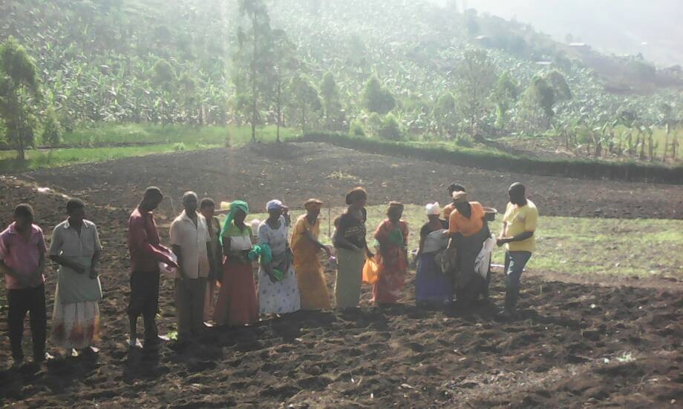

Prepared by
………………………………

Nakayaga Resty

